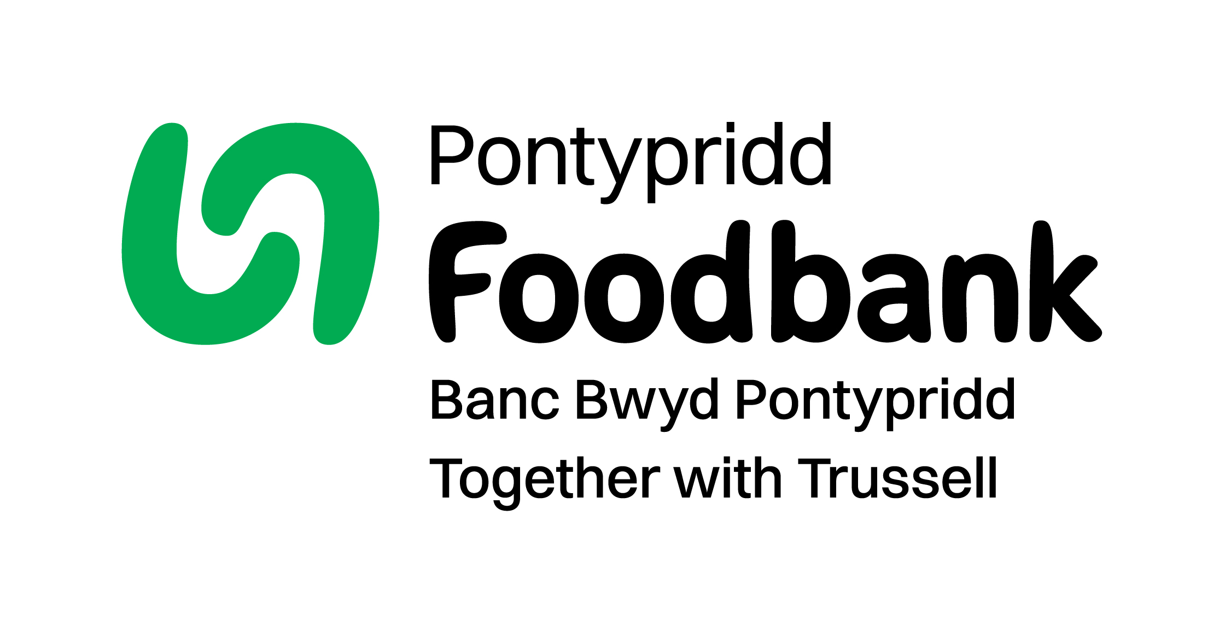

Trustee Application Form

Thank you for your interest in becoming a Trustee of Pontypridd Foodbank. In order for us to process your application please answer the following questions:
(If you have any queries about your application or would like help completing the form, please contact Liz Pearce, Chair of Trustees – liz@pontypridd.foodbank.org.uk

Your details:

Title
Full name
Address

Telephone
Email
Occupation

Qualifications

Please provide details of two people who will act as referees for you. (These should be people unrelated to you):

Name
Email

Telephone
Relationship to you

Please tell us which of the following skills or experience you could bring to our Board.
Mark ‘P’ for a primary skill, or ‘S’ for a secondary skill

 | P/S |  | P/S
Human resources |  | Premises management
Finance/accounting |  | Social media/website skills
Fundraising |  | Welfare benefits system
Legal |  | Bid writing
Business management |  | Knowledge of the local community
Marketing/PR |  | Administrative skills
Health and wellbeing |  | Other (Please outline below)

* Other skills:

Please tell us why you want to become a trustee of Pontypridd Foodbank and how you think your own skills and experience would enable you to fulfil the role of a Trustee as described in the Role Description (300 words)

Would you be willing to have a DBS criminal record check?

Yes No

Trustee applicant’s declaration of eligibility:

I declare that:

      - I am over the age of 18.
      - I do not have an unspent conviction for one or more of the offences listed here
      - I do not have an Independent Voluntary Arrangement (IVA), debt relief order and/or a bankruptcy order
      - I have not been removed as a trustee in England, Scotland, Northern Ireland or Wales (by the Charity Commission or Office of the Scottish Charity Regulator or The Charity Commission for Northern Ireland)
      - I am not under a disqualification order under the Company Directors' Disqualification Act 1986.
      - I have not entered a composition or arrangement with creditors, or have an individual voluntary arrangement (IVA) and I am not on the Insolvency Service Register
      - I have not been disqualified by the Charity Commission nor have I been found guilty of disobedience to an order or direction of the Charity Commission
      - I am not a disqualified company director
      - The information I have provided is true, complete and correct
      - I understand that it is an offence under section 60(1)(b) of the Charities Act 2011 to knowingly or recklessly provide false or misleading information
      - I undertake to fulfil my responsibilities and duties as a trustee of Pontypridd Foodbank in good faith and in accordance with the law and within Pontypridd Foodbank’s objectives/mission and Code of Conduct for trustees.
      - I do not have any financial interests in conflict with those of Pontypridd Foodbank (either in person or through family or business connections) except those that I have formally notified in a conflict of interest statement. I will specifically notify any such interest at any meeting where trustees are required to make a decision which affects my personal interests, and I will absent myself entirely from any decision on the matter and not vote on it.

Is there anything else you’d like to tell us about yourself?

How did you hear about becoming a trustee at Pontypridd Foodbank?

Data protection
Pontypridd Foodbank is committed to protecting data privacy and will process your personal data in accordance with current data legislation. Your data will only be used for purposes relating directly to your trustee activity

Declaration

I confirm that the above information is complete and correct. I consent to the processing of this data in the consideration of my application and during the course of my trusteeship, if applicable.

Signature:

Date:

Please return completed form to: liz@pontypridd.foodbank.org.uk or to Pontypridd Foodbank, Riverside Centre, Nile Street, Treforest, Pontypridd CF37 1BW

Thank you! / Diolch

